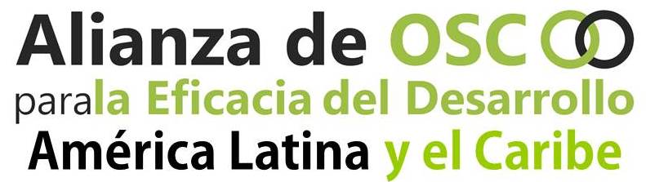

Latin America and the Caribbean, October 8th, 2019
On the escalation of the repression against social movements in Ecuador
The entities that make up the Alliance of Organizations for Development Effectiveness in Latin America and the Caribbean -AOED- strongly repudiate the acts of violence, repression and intimidation carried out by the Lenin Moreno government in our sister Republic of Ecuador on the social movements that are exercising their right to protest against the adjustment measures imposed by the International Monetary Fund (IMF) - that include a significant reduction of living conditions, a labor reform and ignorance of workers' rights. We demand the immediate cessation of the violence and of the curfew, which means a suspension of the rule of law and the respect of constitutional guarantees.
As an Alliance promoting and defending Human Rights, we consider the violent and excessive actions of the police forces endorsed by the State to be unacceptable. The State, that should protect the most vulnerable sectors, chooses instead to repress the indigenous and peasant communities that see their possibilities for the right to food and food sovereignty threatened - which is aggravated by the price hikes, especially regarding the basic food basket. In this context, the government has attacked the legitimate exercise of the right to assembly and protest of the Ecuadorian people.
In line with the Belgrade Call to Action (April 2019), we call on the authorities to stop the aggressions against human rights defenders and the undermining of democratic participation: “The Sustainable Development Goal 16 United Nations on peace, justice and strong institutions is out of reach in places where civic spaces are closed, where civil society cannot freely act with poor and marginalized populations to contribute to and safeguard accountable and inclusive institutions”.
We demand respect for the rights of people to demonstrate peacefully, as well as protection of the rights to freedom of expression and opinion, to peaceful assembly and to participate in public affairs, among others, recognized in the International Covenant on Civil and Political Rights. We denounce the illegal detention of more than 700 activists and demonstrators, which shows the continuous and progressive reduction of civic space in Ecuador.
We call on the international community to provide support for the cessation of hostilities against the most vulnerable, the release of detainees - and to foster a dialogue that could lead the conflict to a peaceful and victim-free resolution, as well as to the immediate restitution of full democratic and civil rights in Ecuador.

Civil society is alert and prepared to defend democracy, hopefully the Ecuadorian political class and the international community will live up to the circumstances.

AOED - LAC

